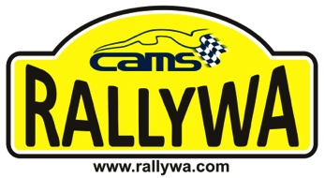

**BP Boddington Fuel Purchase  
Payment Form**

**2019 Better Value Tyres Safari Rally — 1 June 2019**

**Event Secretary – Christine Sefton; Email:** [**boddington@rallywa.com**](mailto:boddington@rallywa.com) **Mob: 0419 260 660  
Promoter: The Light Car Club of WA ABN: 93 553 911 561**

**\*\*\*Form to be delivered to BP Boddington\*\*\***

|  |  |  |  |
| --- | --- | --- | --- |
| **Given Name: Address:**  **Suburb:**  **Mobile:**  **Email:**  **Civil Drivers Licence #:** | **Surname:**  **State: Phone:**  **Fax:**  **Issuing State:** | **Postcode:** | **Car Number** |

**Card Type:** Visa **or** Mastercard

**Card Number:**

**Expiry (MMNY): CVN: Name on Card:**

I agree for this credit card to be debited with all fuel purchased from BP Boddington throughout this event. I agree to sign a logbook each time I purchase fuel.

**Cardholder Signature: X**

**Please note:**

* **This form MUST be delivered directly to BP Boddington, 38 Bannister Road, Boddington**
* Where required please collect a **Tax Invoice** for Fuel Purchases **BEFORE** leaving Boddington

Card sighted by BP Boddington

Ver 1 - 20170127

|  |  |
| --- | --- |
|  | 2019 Better Value Tyres Safari Rally is a SMOKE FREE event |

